Manufacturing Plan
Laser Cutting (Wood)
Base Plate | 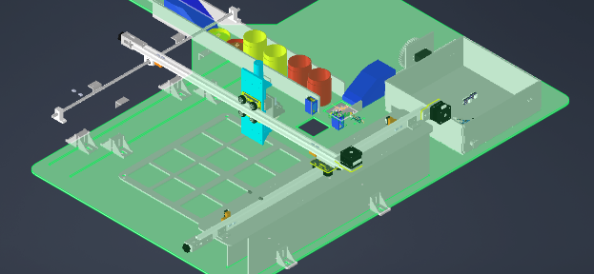
Robot supports (3 plates) ×2 | 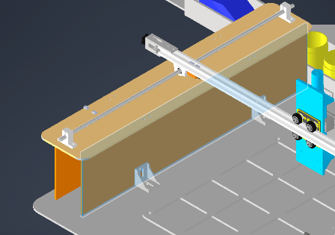
Storage Grid | 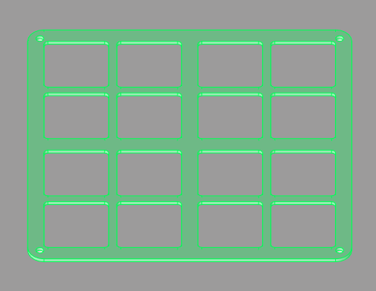
Feeder side railing ×2 | 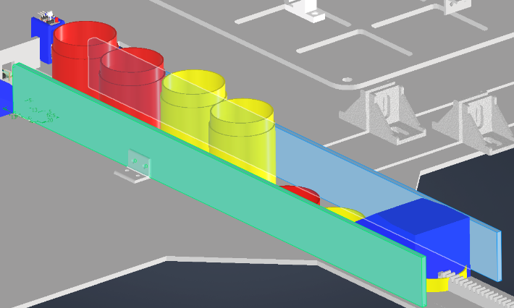
Racks and Pinions | 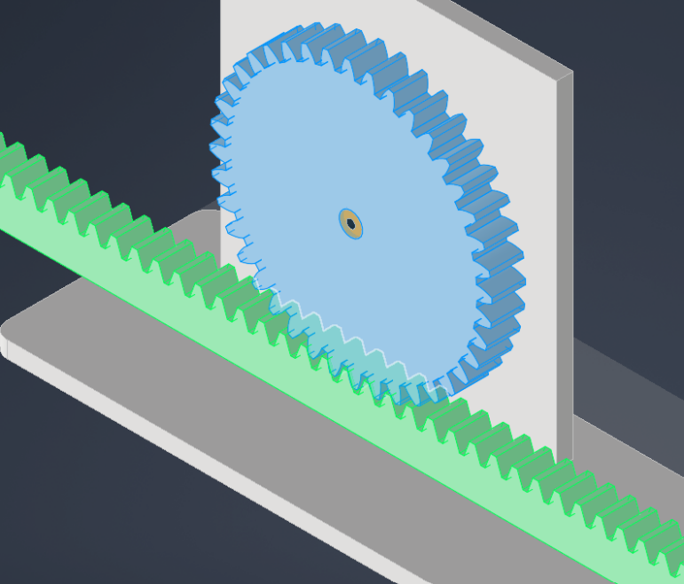
Servo Motor supports ×2 | 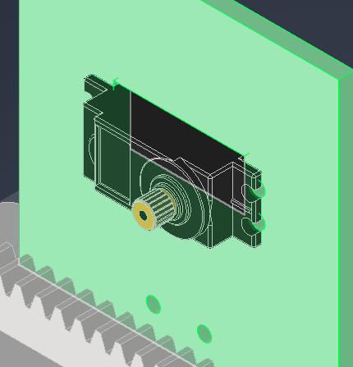
Control box (electrical box) | 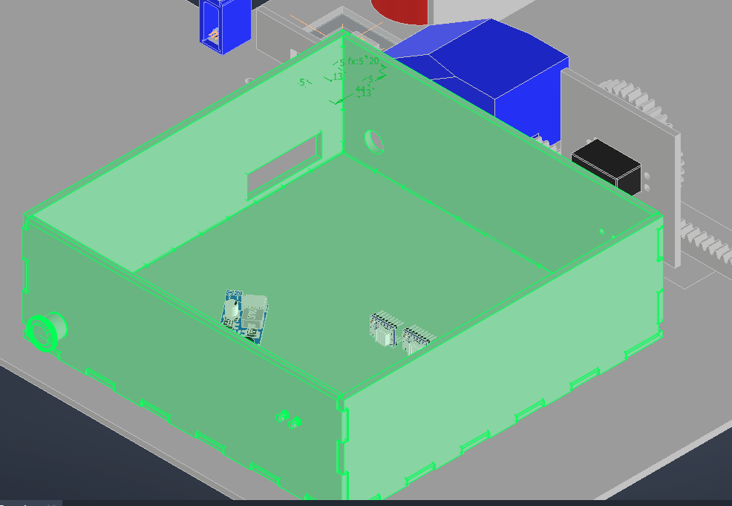
3D- Printing (Plastic)
Pusher punch ×2 |  | 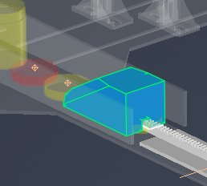
LASER transmitter/receiver holder ×2 |  | 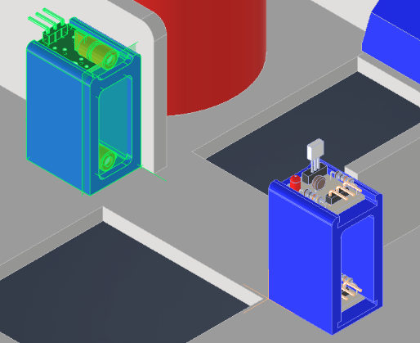
Colour sensor mounting bracket |  | 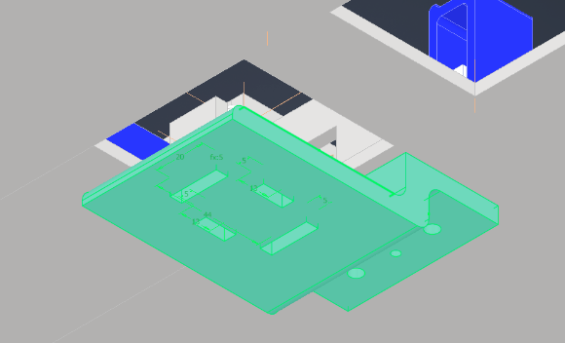
Z-Axis holders |  | 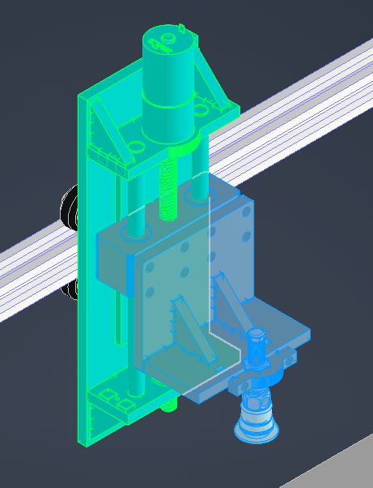
Standard Parts (Steel)
Nuts and Bolts
Aluminium extrusions ×2 |  |  | 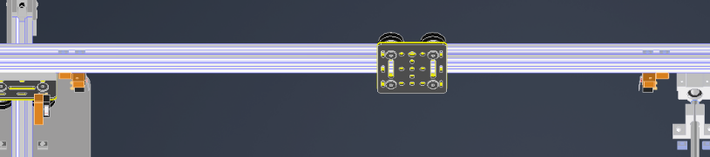
Gantry ×2
Brackets |  |  | 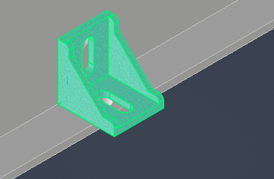
Timing Belt ×2
Linear Bearing |  |  | 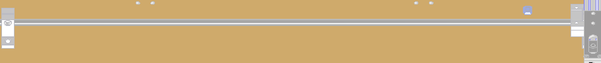
Motors, sensors etc

